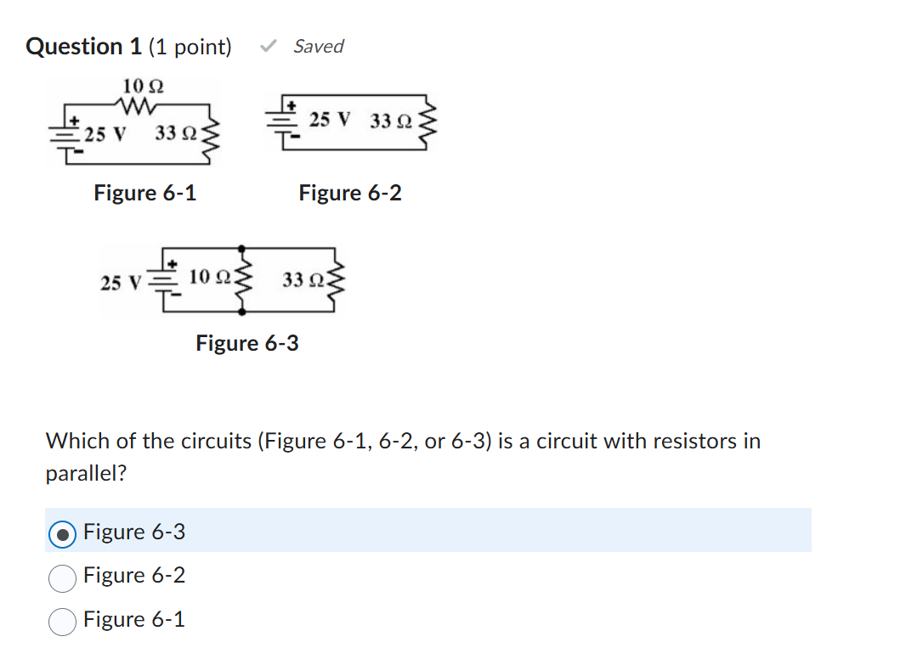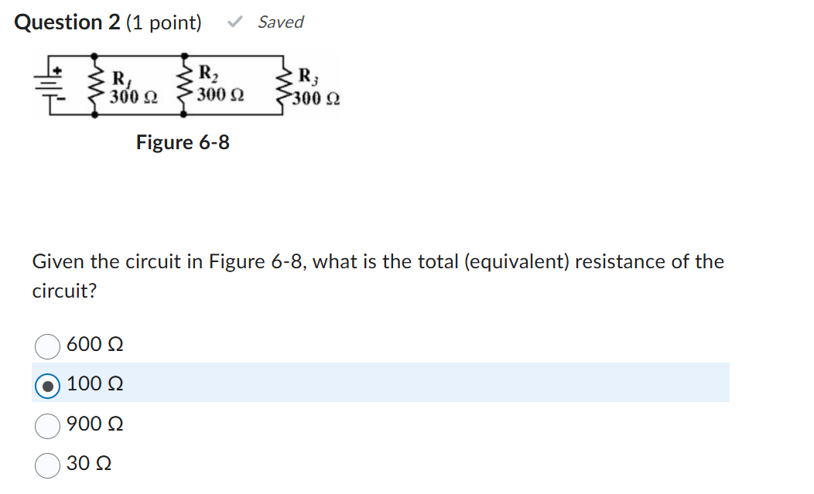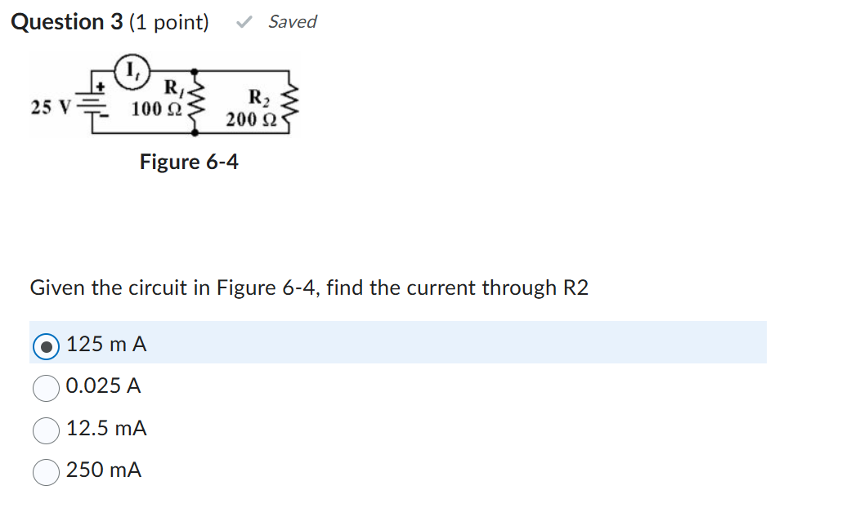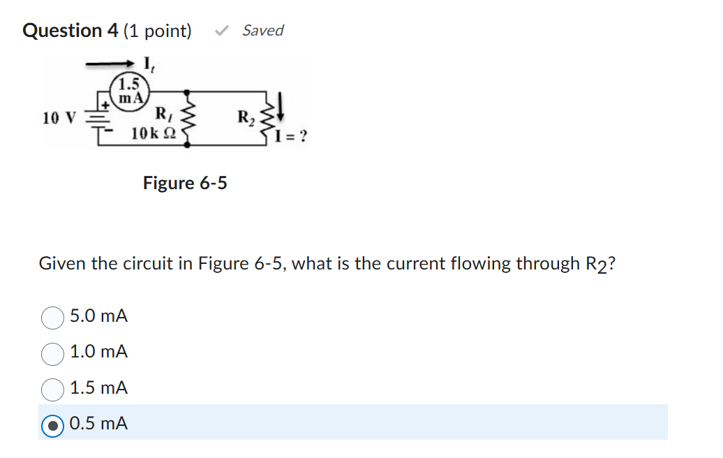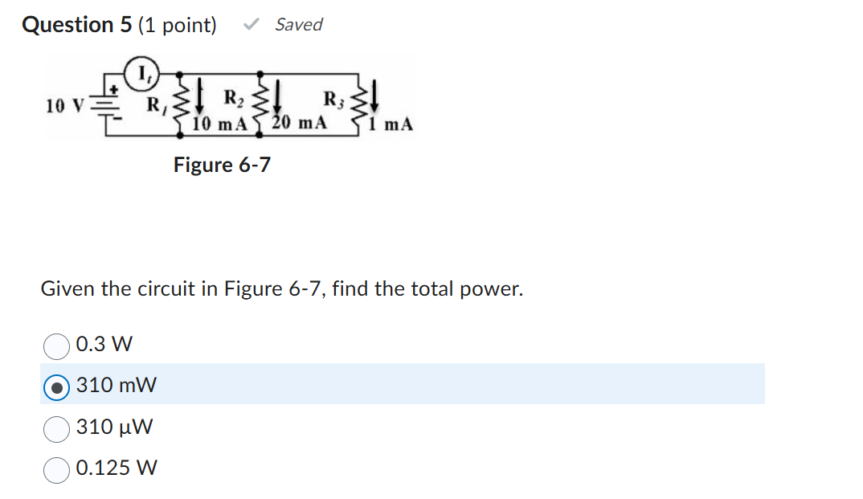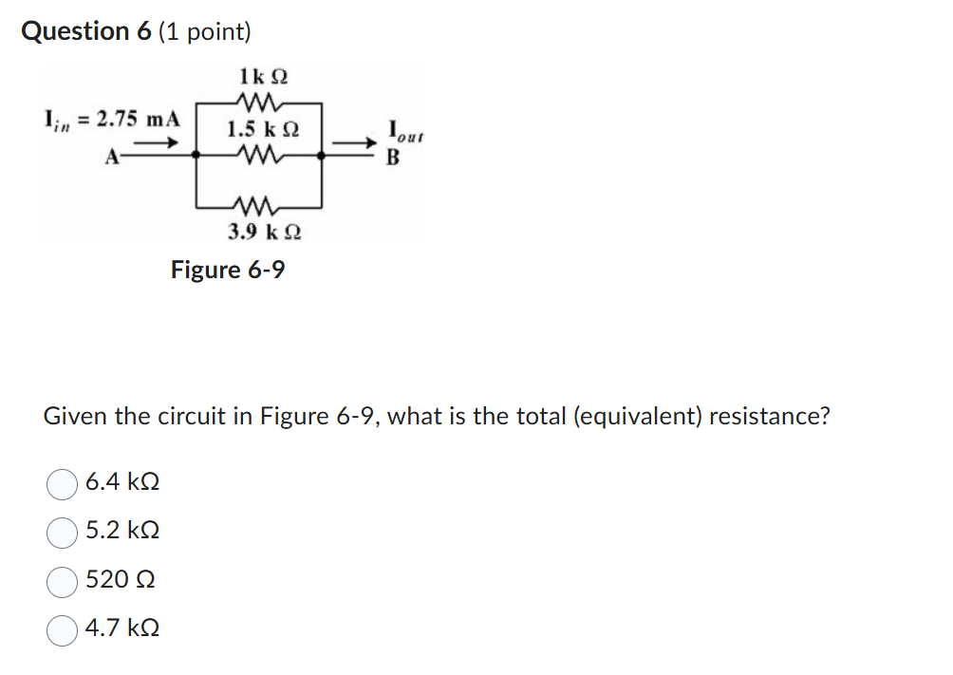
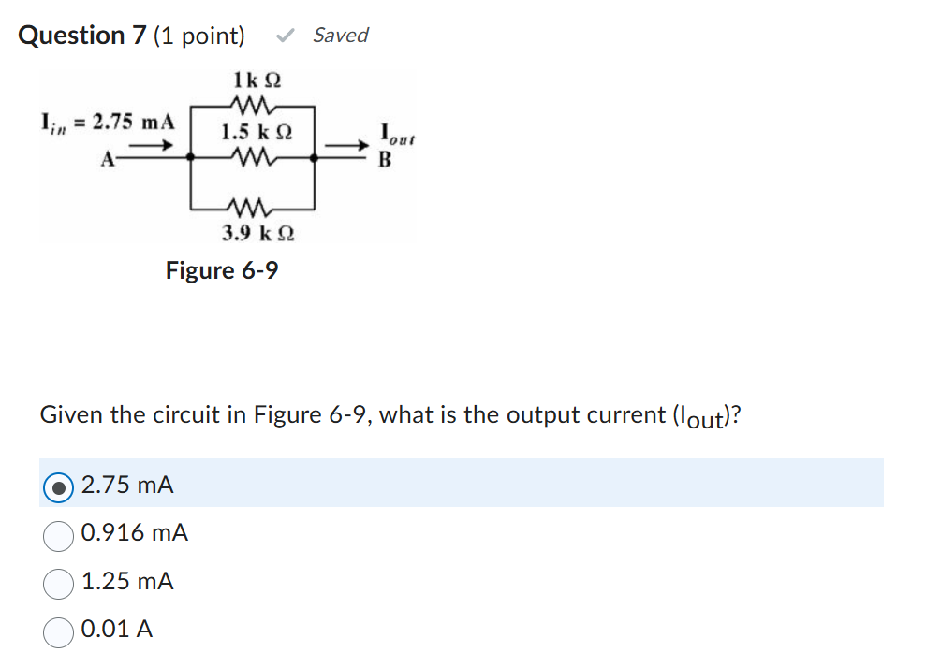

Question 8 (1 point)

Saved
Kirchhoff's law for parallel circuits states that the:
Question 8 options:
sum of currents into a junction is equal to the difference of all the branch currents.
sum of all branch voltages equal zero.
sum of the total currents flowing out of a junction equals the sum of the total currents flowing into that junction.
total circuit resistance is less than the smallest branch resistor.
Question 9 (1 point)

Saved
Circuit analysis should reveal that the smallest resistance in a parallel circuit has the:
Question 9 options:
most voltage
most current
least voltage
least current
Question 10 (1 point)

Saved
The total resistance of two resistors in parallel is equal to the:
Question 10 options:
value of one branch resistor divided by the sum of their R values.
sum divided by the product of the two resistors.
product of their R values divided by the sum of the two resistors.
source voltage divided by any of the two branch resistors.

